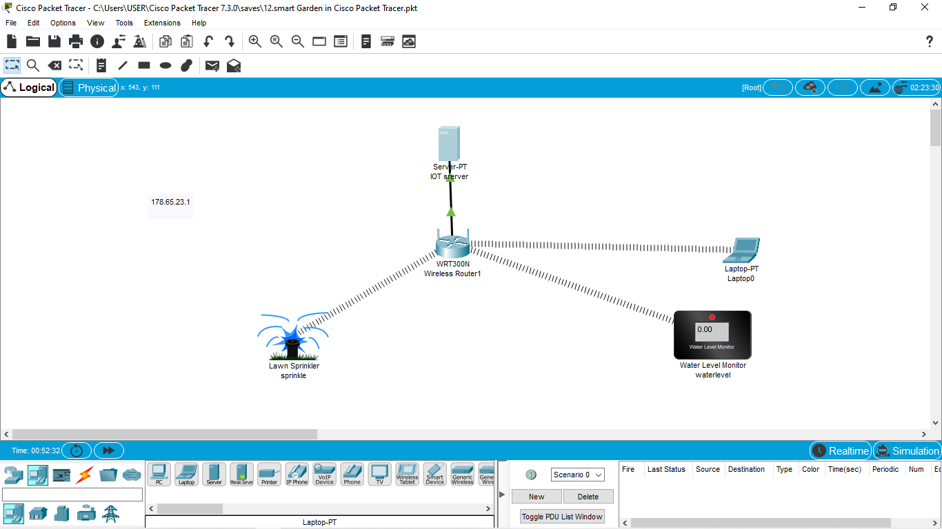

Smart Garden in Cisco Packet Tracer